**Quantum Entanglement**

Danielle Hu, Dr. Kun Yang, Mohammad Pouranvari

*National High Magnetic Field Laboratory and Department of Physics, Florida State University, Tallahassee, Florida 32306*

The concept of quantum entanglement will be introduced and explored conceptually and mathematically. These representations of entanglement will be shown algebraically in the form of matrices and vectors. In order to understand the derivation of eigenvalues and eigenvectors of Pauli Matrices, an introduction to Schrödinger’s time independent equation will be discussed. The singlet state, also known as spin-0 state, will be the main focus of entanglement in this paper since this state is the most entangled state which two particle systems can achieve.

**I. Introduction**

The concept of entanglement disturbed physicists during the development of quantum mechanics. Albert Einstein in particular refused to fully accept this explanation and described this phenomenon as “spooky action at a distance.”1 When two particles entangle, they become bonded in a mysterious way. By measuring the spin of one particle, the spin of the other entangled particle would instantaneously change its spin to the opposite spin of the first particle. If the first particle showed spin up, then the second particle would have changed to spin down; if the first particle showed spin down, then the second particle would have changed to spin up.

Instead of conducting experiments to understand the concept of entanglement, the majority of its qualities can be shown through mathematical representations either in algebraic form or in differential form. This paper will strictly use linear algebra to introduce quantum entanglement.

**II. The Stern-Gerlach Experiment**

Basic properties of particle spin were observed in 1922 by Otto Stern and Walther Gerlach. The results of their experiment showed that particles possessed intrinsic properties of angular momentum. The experiment shot a beam of silver atoms through two slit and towards a glass slate. In between the slits and the slate, however, is a non-uniform magnet that would, in theory, direct the silver atom towards random directions, depending on the orientation of the atom.

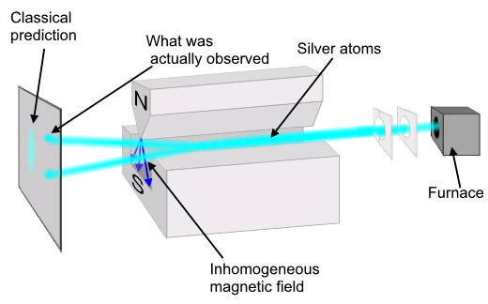

*Figure 1|­­­2*

However, when the experiment was conducted, Stern and Gerlach observed that instead of random designs on the slate, a pattern formed that suggested an upward or downward motion of the particles. There were no silver atoms found in the middle of the slate which countered classical predictions.

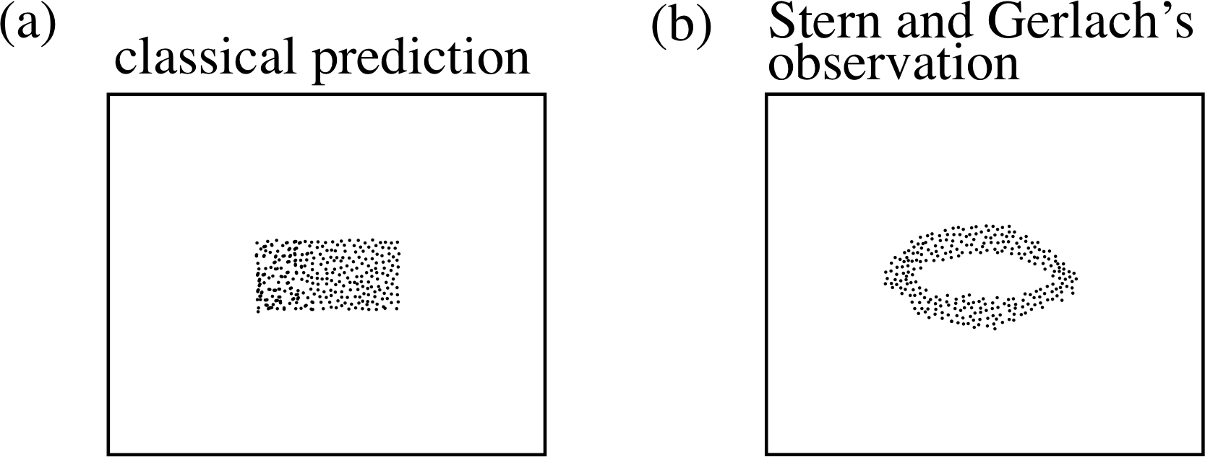

*Figure 2|3*

**III. (a) Schrödinger’s Equation**

HΨ = EΨ

Erwin Schrödinger derived a differential equation to calculate the quantum state of certain physical systems. The above equation is Schrödinger’s equation independent from time. “H” represents the Hamiltonian operator, “Ψ” stands for the wave function, and “E” is the total energy of the system. This equation takes the form of eigenvalue equations where “H” parallels the matrix “A”, “Ψ” represents the eigenvectors “ν”, and “E” equals the eigenvalue “λ.”

The Hamiltonian operator represents the forces and environment acting on a particle. When solving Schrödinger’s equation, a Hamiltonian operator can be represented by a hermitian matrix. These hermitian matrices are often derived from experiments and calculations. By solving for the eigenvalues “E,” the eigenvectors of “Ψ” can be solved for and normalized. Since quantum entanglement focuses on the state of particles, such as spin up or spin down, normalizing is crucial to representing the states of the particles in the form of probability.

In order to solve for these eigenvalues and eigenvectors, Schrödinger’s equation can be manipulated to the form:

(H – IE)Ψ = 0

(Where “I” represents the identity matrix)

From that point, the eigenvalues of “E” can be calculated by taking the determinant of (H – IE) set equal to zero. Once the values of “E” have been derived, the eigenvectors can be solved for by substituting the Hamiltonian and the eigenvalues.

**III. (b) Pauli Matrices**


\sigma_1 = \sigma_x =
\begin{pmatrix}
0&1\\
1&0
\end{pmatrix}



\sigma_2 = \sigma_y =
\begin{pmatrix}
0&-i\\
i&0
\end{pmatrix}



\sigma_3 = \sigma_z =
\begin{pmatrix}
1&0\\
0&-1
\end{pmatrix}


*Figure 3|4*

These three matrices, when multiplied by the quantum value ħ/2 are hermitian quantum operators that illustrate spin properties along three orthogonal planes (Sx, Sy, and Sz). By using Schrödinger’s equation, the eigenvalues and eigenvectors can be derived. The eigenvalues for all three Pauli matrices are ±1; however, their eigenvectors differ from one another, which can be seen in figure 4.


\begin{array}{lclc}
\psi_{x+}=\displaystyle\frac{1}{\sqrt{2}}\!\!\!\!\! & \begin{pmatrix}{1}\\{1}\end{pmatrix}, & \psi_{x-}=\displaystyle\frac{1}{\sqrt{2}}\!\!\!\!\! & \begin{pmatrix}{1}\\{-1}\end{pmatrix}, \\
\psi_{y+}=\displaystyle\frac{1}{\sqrt{2}}\!\!\!\!\! & \begin{pmatrix}{1}\\{i}\end{pmatrix}, & \psi_{y-}=\displaystyle\frac{1}{\sqrt{2}}\!\!\!\!\! & \begin{pmatrix}{1}\\{-i}\end{pmatrix}, \\
\psi_{z+}=                                          & \begin{pmatrix}{1}\\{0}\end{pmatrix}, & \psi_{z-}=                                          & \begin{pmatrix}{0}\\{1}\end{pmatrix}.
\end{array}


*Figure 4|4*

With spin-1/2 particles, the only directions which the particles can travel are either up (by ħ/2) or down (by - ħ/2). Spin up is often represent by | ↑ > and spin down is often shown as | ↓ >.

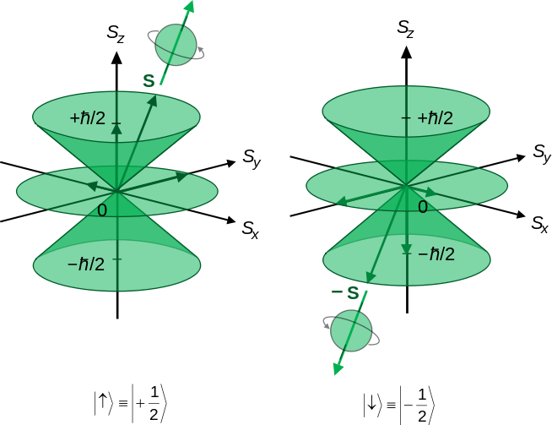

*Figure 5|5*

**IV. Two Particle Systems – Singlet State**

In two particle systems, the states of both particles are observed. The singlet state represents the most entangled state which two particles can achieve. The singlet utilizes the Pauli matrix on the “z” axis due to the direction of either up or down.

| Singlet > = $\frac{1}{√2} [ \left| ↑_{A} ↓_{B} > - \right| ↓_{A} ↑_{B} > ]$

$$\frac{1}{√2} [ \left| ( {\begin{matrix}1 \\ 0\end{matrix} )}_{A} ( {\begin{matrix}0 \\ 1\end{matrix} )}_{B}> - \right|( {\begin{matrix}0 \\ 1\end{matrix} )}_{A} {( \begin{matrix}1 \\ 0\end{matrix} )}_{B}> ]$$

When particles are entangled in the singlet state, they maintain a relationship that can be witnessed across large distances and at speeds faster than the speed of light. The singlet equation includes both possibilities of the particles. If particle A has a spin up, then particle B has a spin down as shown in | . The same occurs for when the particle of A has spin down: spin B must have spin up as shown in |. In order to show this relationship between the two particles, three steps have to occur.

1. Normalization
2. Expansion
3. Measurement

Since one of the objectives is to acquire more information about the state of particles, normalizing eigenvectors allows for results to equal one. This normalization therefore represents the probability of the different positions which a particle may exist at a given time. To normalize, the components of the singlet must be multiplied by the transpose of the singlet. Therefore the column matrices would be converted to row matrices; the row matrices would then multiply the column matrices and set equal to one. In the case of the singlet, the particles have already been normalized due to the multiplication of $\frac{1}{√2}$ in the beginning.

After normalizing the state, both particles can be expanded separately in terms of the eigenvectors.

For particle A, the expansion would yield

SzA  = ( =

For particle B, the expansion would yield

SzB  = ( =

The coefficients $\frac{1}{√2}$ in front of all four eigenvectors are referred to as the probability amplitudes for the particle states. By taking the absolute value of these amplitudes and squaring them, the results will equal the probabilities for the related states. By expanding this singlet the coefficients for both spin up and spin down, particles A and B, result in a ½ chance. Because of the intricacies of quantum physics, the only way to actually determine the spin of the particles would be to measure their actually states at a given time.

Under the singlet state, the measurement of one of the particles allows for the state of the second particle to be identified. Once measurement on one of the particles occurs, the second particle jumps to a new state due to their entangled properties. The probability of this change can be depicted through the manipulation of the singlet. For example, if particle A is measured and its spin is determined to be spin down, the state of the two particle system jumps to |. This new state displays the state of particle B as spin up, the opposite of particle A. This state can also be represented through coefficients of expansion. If this state is represented, the following state shows an expansion of

$( \begin{matrix}0 \\ 1\end{matrix} )$ = a ($\begin{matrix}1 \\ 0\end{matrix} )+b ( \begin{matrix}0 \\ 1\end{matrix} )$

This can then be separated into

0 = a

1 = b

Since the coefficient “b” represents the probability amplitude for spin down, this numeric representation shows a 100% probability of spin down.

**V. Conclusion**

There are many intricacies to entanglement. The singlet state shows the most entangled state which two particles can achieve. With the discovery of quantum entanglement, new applications to technology and networking have achieved ground. The possibility of teleportation across large distances can now be scientifically explained using the properties of entanglement.

**VI. References**

1. "Spooky action at a distance" aboard the ISS. (2013, April 9). *Institute of Physics*. Retrieved July 26, 2013, from http://www.iop.org/news/13/apr/page\_59834
2. kind, n. i. (2013, July 21). Stern–Gerlach experiment. *Wikipedia*. Retrieved July 26, 2013, from http://en.wikipedia.org/wiki/Stern%E2%80%
3. calculation, d. a. (n.d.). 4.3 The Stern–Gerlach experiment and electron spin.*PPLATO*. Retrieved July 26, 2013, from http://www.met.reading.ac.uk/~gd900856/PPLATO/h-flap/p8\_3.html#section\_4.3
4. Pauli matrices. (2013, July 14).*Wikipedia*. Retrieved July 26, 2013, from http://en.wikipedia.org/wiki/Pauli\_matrices
5. Spin-½. (2013, July 9). *Wikipedia*. Retrieved July 26, 2013, from http://en.wikipedia.org/wiki/Spin-%C2%BD